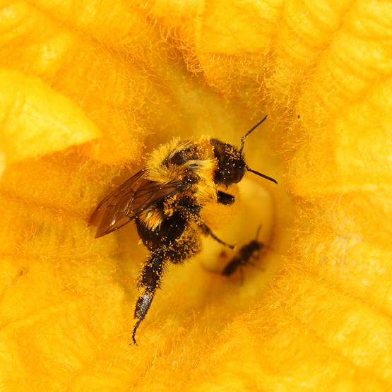
Opportunity: Assist with Insect Population Ecology and Management in Vegetable Crops. Experience includes field research in commercial farms and laboratory tasks.

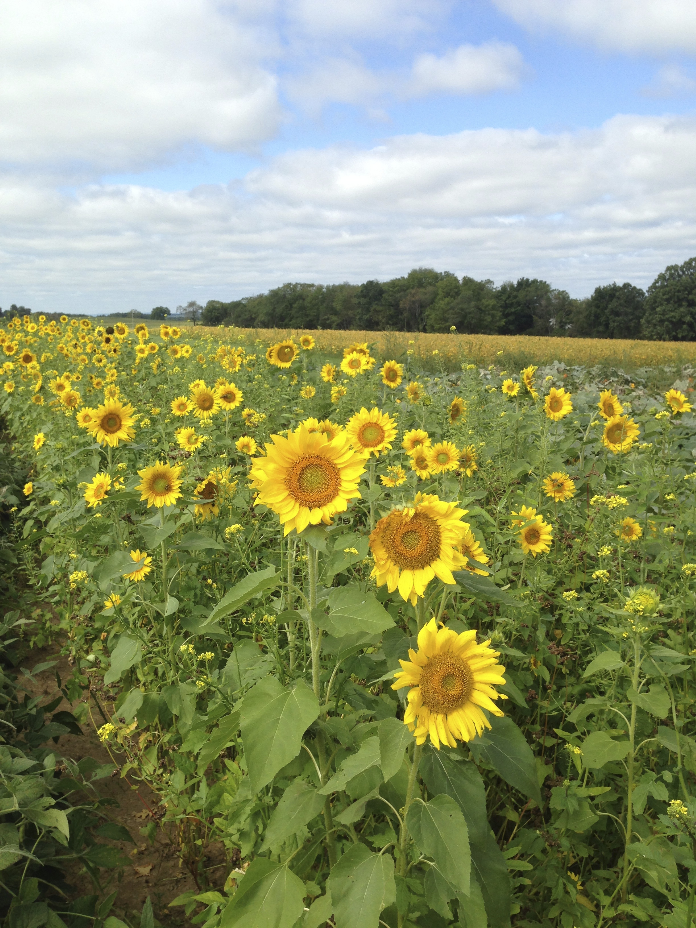
Duties: Advance information exchange via the web-mapping softward tools focusing on pests of sweet corn. Establish and service pheromone traps. Help conduct studies to manage a new invasive pest of allium (onion, garlic, leek) crops. Help with studies evaluating resistance to Bt genes. Assist in data management, compile and summarize data, routine lab maintenance.

Requirements: Ability to work independently and in small teams in agricultural and lab settings, and the ability to work where bees are active. Ability to travel to field sites, including limited overnight travel. Agricultural, entomology, or ecology experience preferred. A driver’s license is required. Must be willing to learn basic insect and plant identification. Pursuing or completed Bachelor’s degree, an understanding of agricultural systems, and good communication skills.

Employment period: Starting date in early April. Part time work extends into the fall.

Contact: Shelby Fleischer (sjf4@psu.edu)

Department of Entomology

