- Open any file Explorer window and go to This PC
- Click the Computer Tab
- Then select Map a Network Drive
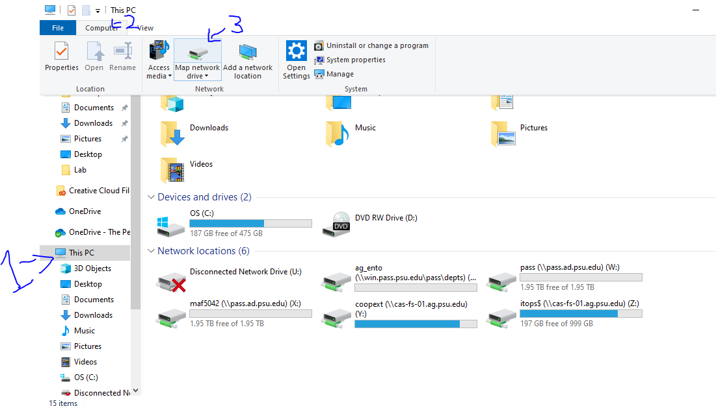
- Set Drive: as T:
Folder as \\win.pass.psu.edu\pass\dept\ag_ento\
Check both boxes (See below pic)
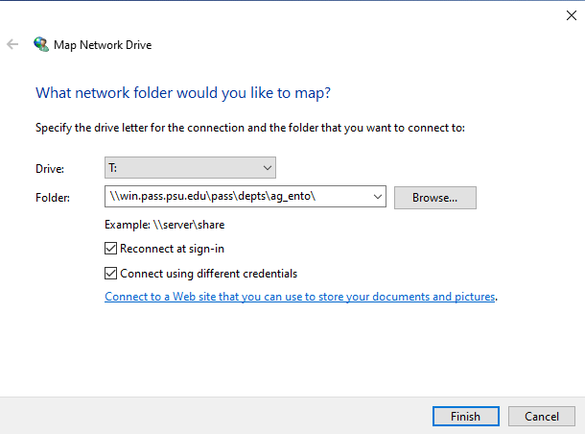
- You will be prompted for password. In the user field put in userid@dce.psu.edu and your Penn State password
- And now you are connected and should see it mapped when you go to this pc on your computer in the future
- You need to be on a PSU network or connected to VPN to reach the folder

Instructions for MAC users
- In the Finder, use the “Go” drop down menu and choose “Connect to Server...”
- In the window type: smb://win.pass.psu.edu/pass/depts/ag_ento
- “Connect”
- When prompted for name and password, use your email with the ending “@dce.psu.edu” and your normal Penn State password.

